Kadar M Anwar

Collaboration with Sean Baker

ISAT 252

Lab 2

Dr. Anthony Teate

Honor Pledge: I have neither given nor received help on this assignment that violates the spirit of the JMU honor code. *Kadar M Anwar and Sean Baker*

**Problem 1:** You have been asked to write an algorithm that computes the maximum of three numbers x, y and z

1. Inputs for each task: number x, y and z
2. Outputs: maximum of x, y or z
3. Psuedocode:

a. Start

b. Get x input Input

c. Get y input Input

d. Get z input Input

e. Perform a comparison Process

i. Is x>z? If true, continue Decision

1. If z>y = true, output Z Decision and output

2. Else output Y Output

ii. Else

1. If x>y = true, output x Decision and output

2. Else output Y Output

f. Stop

4. Algorithm flowchart

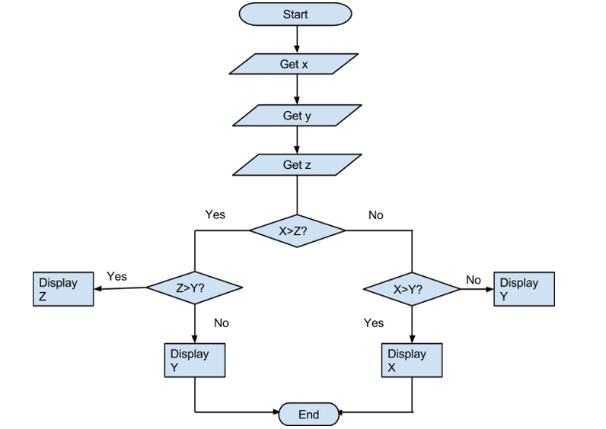

**Problem 2**: Write an algorithm to compute the sum of the first n terms of the harmonic series.

1. Inputs: Value of X
2. Outputs: sum of first n terms in the harmonic series
3. Pseudocode:
   1. Start
   2. Get the value of X Input
   3. Initialize sum to 0 Process
   4. Initialize N to 0 Process
   5. While N < X Decision
      1. Increment N Process
      2. Add 1/N to the current Sum Process
   6. Print Sum Output
   7. End
4. Algorithm Flowchart

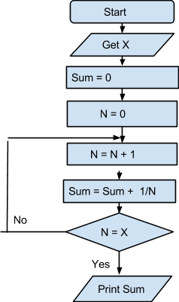

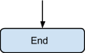

**Problem 3:** You have been asked to write a program that will allow the user to enter a temperature. Your program should allow the user to do 2 separate tasks: a) Change the temperature from Celsius to Fahrenheit. b) Change the temperature from Fahrenheit to Celsius.

1. Hierarchy of tasks
   1. Get the temperature input
   2. Decide if the temperature is F or C
   3. Convert from F to C
      1. multiply input by 5/9th and add 32
   4. Convert from C to F
      1. multiply input by 9/5th and subtract 32
   5. Output the temperature
2. Inputs: Temperature
3. Outputs: Temperature in Fahrenheit, temperature in Celsius
4. Pseudocode
   1. Start
   2. Get temperature Input
   3. Ask user if temperature is F or C Input
      1. if converting to C, multiply input by 5/9 Process
         1. subtract 32 from result Process
         2. output temperature in C Output
      2. if converting to F, multiply input by 9/5 Process
         1. add 32 to result Process
         2. output temperature in F Output
   4. End
5. Algorithm Flowchart

